Login page - <http://www.tgxpress.com/Loginpage.php>

Log in to Insightly to e-Shipment Platform

Sign in

Language: English / 繁體

Customer Code: XXXX

Password: XXXX

Log in

Forgot your password?

New customer

After login page

Welcome “Customer Name”

You last logged in at 10:34 on Friday 15 April 2016

Customer Name: “Customer Name”

Customer Code: “Customer Code”

You are logged in as: “Customer Code”

1. 戶口服務 e-Statement
   1. 月結單詳情 Statement Details
   2. 電子發票 e-Invoice
2. 網上落單 Web-Shipper
   1. 已註冊地址收件 Pick-up at Non-registered Address
   2. 指定地址收件 Pick-up at Registered Address

1. 運件追蹤 e-Tracking
   1. 電子簽收交付証明 Electronic Proof of Delivery

1. 客戶服務 Customer Services
   1. 儲存託運通訊錄 Record Address Book
   2. 網上過往記錄 Archive History
   3. 索取物資 Order Supplies
   4. 更改密碼 Reset Password

Now you can view, download, print or email your proof of delivery image in table.

1. 網上落單 Web-Shipper
   1. 已註冊地址收件 Pick-up at Non-registered Address
   2. 指定地址收件 Pick-up at Registered Address

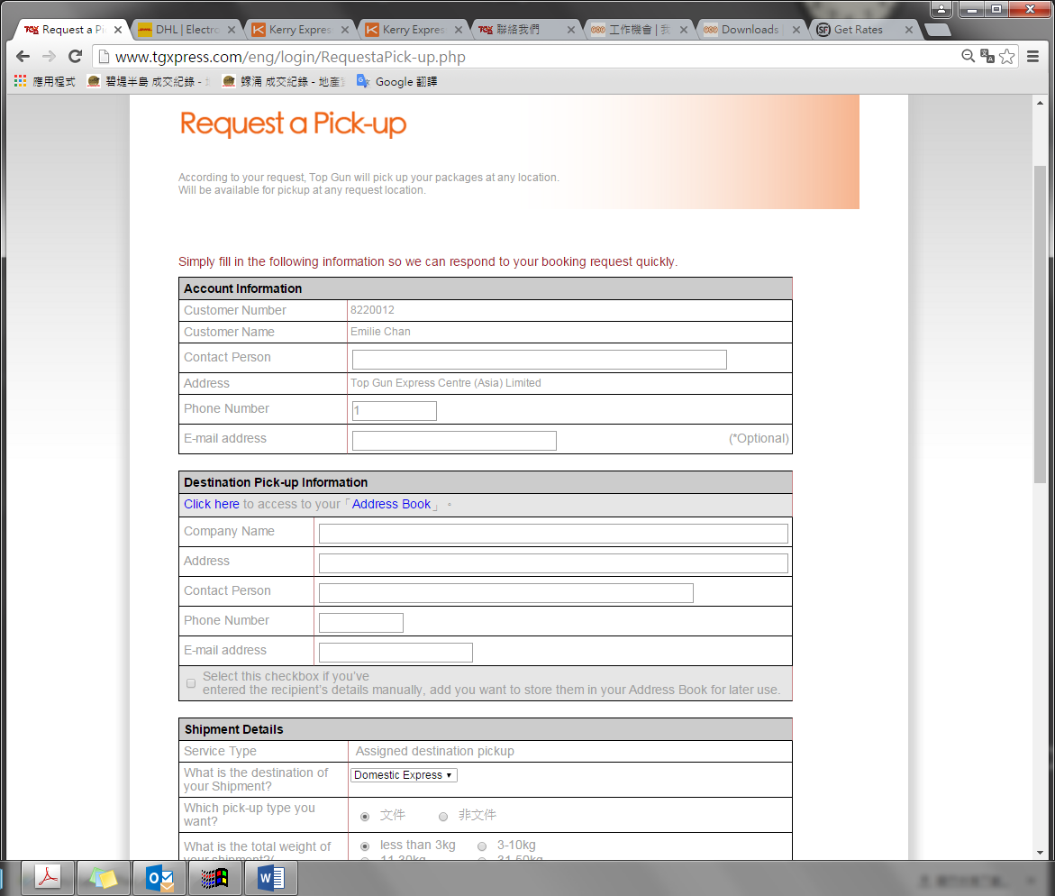

**Address 地址**

Distrist 區域

(HK Island, Kowloon and New Territories, Outlying Island 港島, 九龍, 新界, 離島)

(18區)

|  |  |
| --- | --- |
| 九龍城  大埔  中西區  元朗  屯門  北區  西貢  沙田  東區  油尖旺  南區  荃灣  深水埗  黃大仙  葵青  灣仔  觀塘  離島 | Kowloon City  Tai Po  Central and Western District  Yuen Long  Tuen Mun  North District  Saigon  Sha Tin  Eastern District  Yau Tsim Mong  Southern District  Tsuen Wan  Sham Shui Po  Wong Tai Sin  Kwai Tsing  Wanchai  Kwun Tong  Islands |